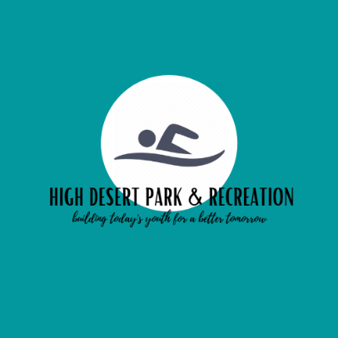

BOARD MEETING AGENDA

April 29th, 2024

1. Call Meeting to order (5pm)

-Attendance:

Budget Board: Ken Higle, Steven Smartt, Tim Scott, Channing Nisbet, Melissa McElhannon.

HDPR Board: Board Chair Becki Graham, District Manager Brandy Branstetter, Rachel Beaubien, Kelly Novak, Tammy Wheeler, Amie Scott

2. Guests:

3. Appoint New Budget Members – Steven Smartt, Tim Scott, Channing Nisbet

4. Budget Message – Park and Recreation District Manager

5. Budget open for discussion

6. Budget Board Approval

7. Adjournment of Meeting