

**Basketball Camp Goals**

*To create a positive learning experience for kids who want to learn how to play basketball**.**

*To renew or spark an interest in basketball.

*To develop basketball concepts and skills for youth.

*To teach simple drills, activities, and games kids can play at home.

*To start summer vacation off with playing some basketball.

KEYS TO SUCCESS AT **BURNS HILANDER CAMP**

* Bring a water bottle and tennis shoes/basketball shoes.
* Bring a positive attitude and be coachable.
* Come to learn and have fun working hard.
* Remember to be early or on time to get the most out of camp.
* Wear comfortable clothes that you can be active in like shorts and t-shirt.
* Remember to encourage yourself and others.

**Sign Up Early to Get Your Camp T-Shirt!**

Register by or before May 27th to secure your t-shirt order. We need at least 2 weeks to get shirts ordered, printed, and delivered to have them ready at basketball camp! Don’t wait, mail registration in today; or drop off at Harney District Hospital Physical Therapy.

Contact US

Coach Kris Sanders, Girls Varsity Basketball Coach

Telephone – 541-647-4136

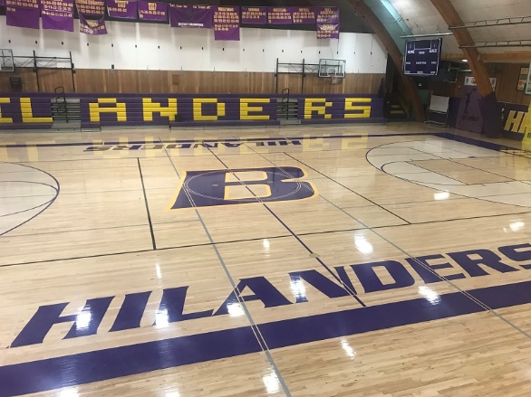

Things to be Excited about…

-Work on developing your skills through fun games and drills.

-Play with other students at your own skill level.

-Learn the proper ways to dribble, pass, and shoot the ball.

-Get to see and learn about basketball from other Burns high school players and coaches.

-Enjoy time with friends on a basketball court and being active.



**Sign Up & Return**

Student Name

Incoming Grade______________

Youth Shirt Size – No Thanks____

Yes Please – **Circle One**

XS S M L XL

4/5 6/8 10/12 14/16 18/20

Parent’s Name

___________________________

Cell #_______________________

Student Medical Concerns or Allergies_______________________________________________

Insurance Co. Name

___________________________

Insurance Policy#_________________________

Waiver of Insurance liability and consent to treat: I hereby waive the HCSD #3 & summer coaching staff from any injury liability. I will take care of my own participant’s injury protection. I also give consent for any medical care determined by a physician for the welfare of my child if I am unable to give consent.

Signed___________________________

Date_____________________________

**Make checks payable to:**

Burns Hilander Basketball Camp

**Send Registration & Checks to:**

Burns High School

1100 Oregon Ave.

Burns, OR 97720

**When:** June 19-21, 2023

**Time:** 9 am -12 pm

**Where:** Burns High School

**Registration Fee:** $40

Includes a camp T-shirt!

$30-Without T-shirt



**2nd ANNUAL Kid’s Summer Basketball is Back!**

This is a 3-day camp for boys & girls 6th-8th Grades at Burns High School!

**Pizza Party**

**Ice Cream**

**Popsicles**

**Prizes**